Canucks at 50: When the expansion hosts 'Sealed' victory with goals galore
Mixed emotions? After all, the 11-5 pounding of the California Golden Seals on March 28, 1971 also marked an end to the Canucks' part in the Guy Lafleur derby
Staff Reporter
Updated: November 14, 2019
In looking at the Canucks history one of the best early memories was the night of Sunday, March 28, 1971 in their first season where they racked up 11 goals against the California Golden Seals, a dominant win that saw the Canucks solidify several firsts along the way.
Sports writer Hal Sigurdson reported on the game that offered some hope for Canucks fans going forward, but also featured some score settling and a bizarre argument over players who didn’t want credit for a goal. Here’s part of what he wrote:
The Vancouver Canucks left for Minneapolis this morning to start their final National Hockey League road trip, still last in the Eastern Division perhaps, but not without a certain feeling of satisfaction.
And why not? They had two new 20-goal men aboard, they had just achieved the distinction of scoring in double figures for the first time and they have remained the only NHL team never to have been shut out.
By tomorrow night they may have cause to wish they had saved some of Sunday afternoon’s firepower for the Minnesota North Stars.
But tomorrow is soon enough to worry about that. Tonight they will be party guests of the kindly boss, Tom Scallen, and there’s that 11-5 victory of the California Golden Seals at the Coliseum to celebrate.
However Scallen and Vancouver general manager Bud Poile may have viewed Sunday’s assault on California goaltenders Gary Smith and Chris Worthy with mixed emotions. The Canucks win, accomplished before a crowd of 14,793, officially ended the Guy Lafleur derby. The Seals, last in the Western Division, are now eight points behind Vancouver with only three games left to play.
That leaves Lafleur, the scoring sensation of the junior Quebec Rampart, to the Montreal Canadiens for the taking. The Canadiens won the Seals’ first amateur draft choice.
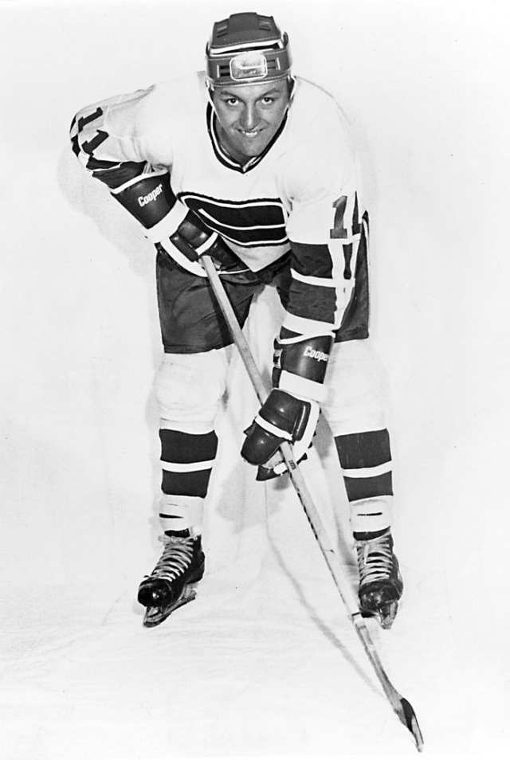
Vancouver Canucks winger Wayne Maki during the Canucks’ inaugural 1970-71 NHL season. PNG files
As for the game it was a day when the goaltenders were left to their own devices and checking was a dirty word. Wayne Maki, in a long and painful slump after a fantastic start, snapped out of it with the first three-goal performance of his professional career.
The burst brought his season’s total to 21 and made him the fourth Canuck to crack the 20-goal barrier.
“I’m so relieved I may even have a Seven Up,” he grinned.
Otherwise the Canucks got two goals from Dale Tallon, the rookie’s 13th and 14th of the season. That gives him one more than Bobby Orr scored in his first NHL campaign.
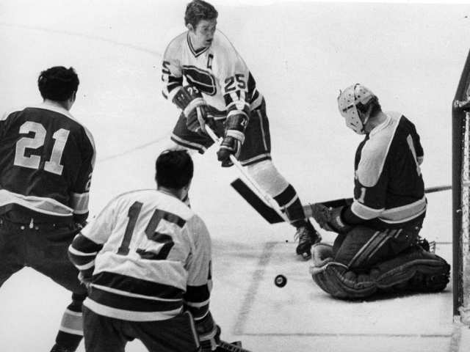
Vancouver Canucks captain Orland Kurtenbach sweeps the puck into the net for his 19th goal of the 1970-71 NHL season against the visiting California Golden Seals on March 28, 1971. Province file photo / PNG
Murray Hall became the Canucks’s fifth 20-goal man in the third period as he tapped in a Mike Corrigan rebound.
For a while it looked like Canucks had a sixth man in the 20-goal club.
Captain Orland Kurtenbach, who had scored his 19th minutes earlier, was credited with his 20th when he drilled a slap shot that wound up behind Smith.
Later the goal was properly credited to Corrigan but only after a bizarre dressing room argument between the second and third periods.
“I don’t want the goal, it belongs to Kurt,” Corrigan kept insisting.
“I want to earn my first 20-goal season,” countered Kurtenbach. “I don’t want it given to me.”
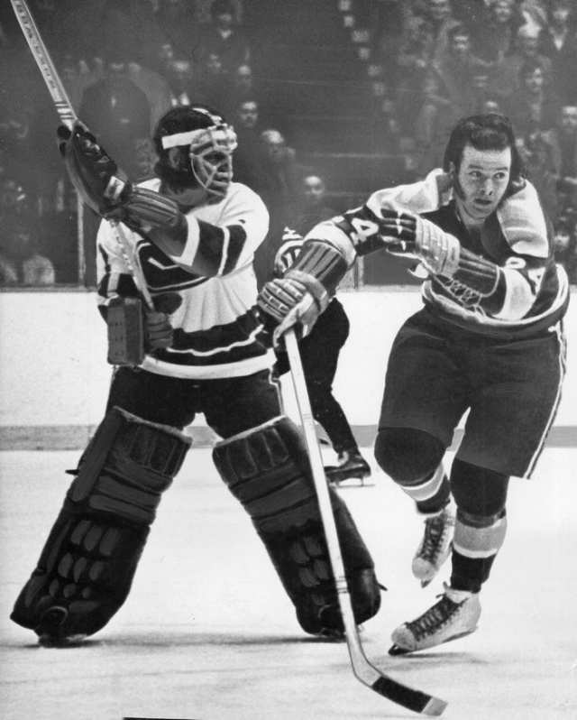
Vancouver Canucks goalie Dunc Wilson clears the puck past charging California Golden Seals centre Bobby Sheehan during a Jan. 31, 1972 NHL game at the Pacific Coliseum. Ray Allan / Vancouver Sun files
Thus you had the odd spectacle of two members of a team frequently desperate for goals both refusing to take credit for one.
The argument was finally settled by Dunc Wilson who said he’d seen Corrigan tip in the shot and that was that. Corrigan had to accept his 21st goal whether he wanted it or not.
Apart from demonstrating the Canucks can score a lot of goals when nobody bothers checking them much, the game also proved Canucks Ted Taylor has a long memory.
In the Canucks first ever exhibition game, the rugged left winger was cut for eight stitches over the eye when Dick Redmond, then with Minnesota but now with California, unloaded on him while a linesman had his arms pinned.
Twice Sunday young Redmond was flattened by crunching, and slightly illegal, Taylor body checks.
Is the score even now?
“Not quite,” said Taylor.

As the Canucks Celebrate their 50th season we’re looking back at the moments that stand out as the biggest in franchise history on the ice and off, good, and a few bad. We will highlight the top moments from the 1970s through November, the ’80s in December, the ’90s in January, the ’00s in February and the ’10s in March. If you have any great memories of where you were when your favourite moments happened, or what they meant to you, send them to pchapman@postmedia.com

